Latin America Environmental Problems Graphic Organizer

Mexico City Air Pollution

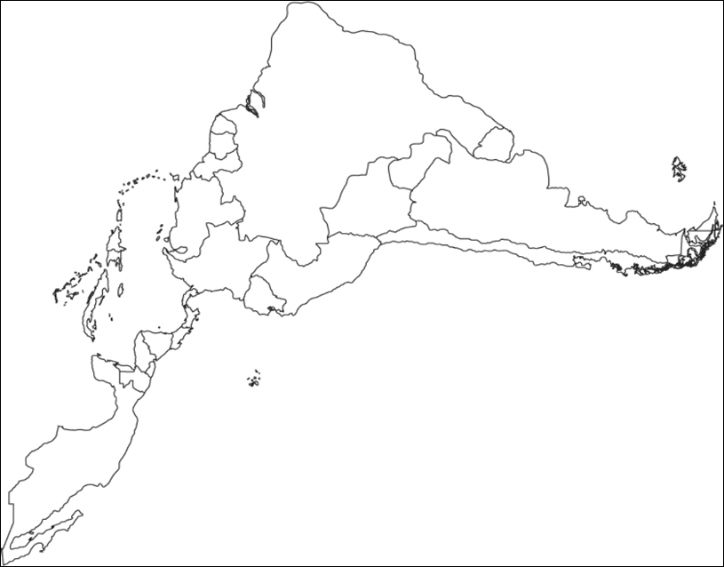
Deforestation of
Amazon Rain Forest

Oil Pollution in Venezuela

.

